# Functional Description

## User interface:

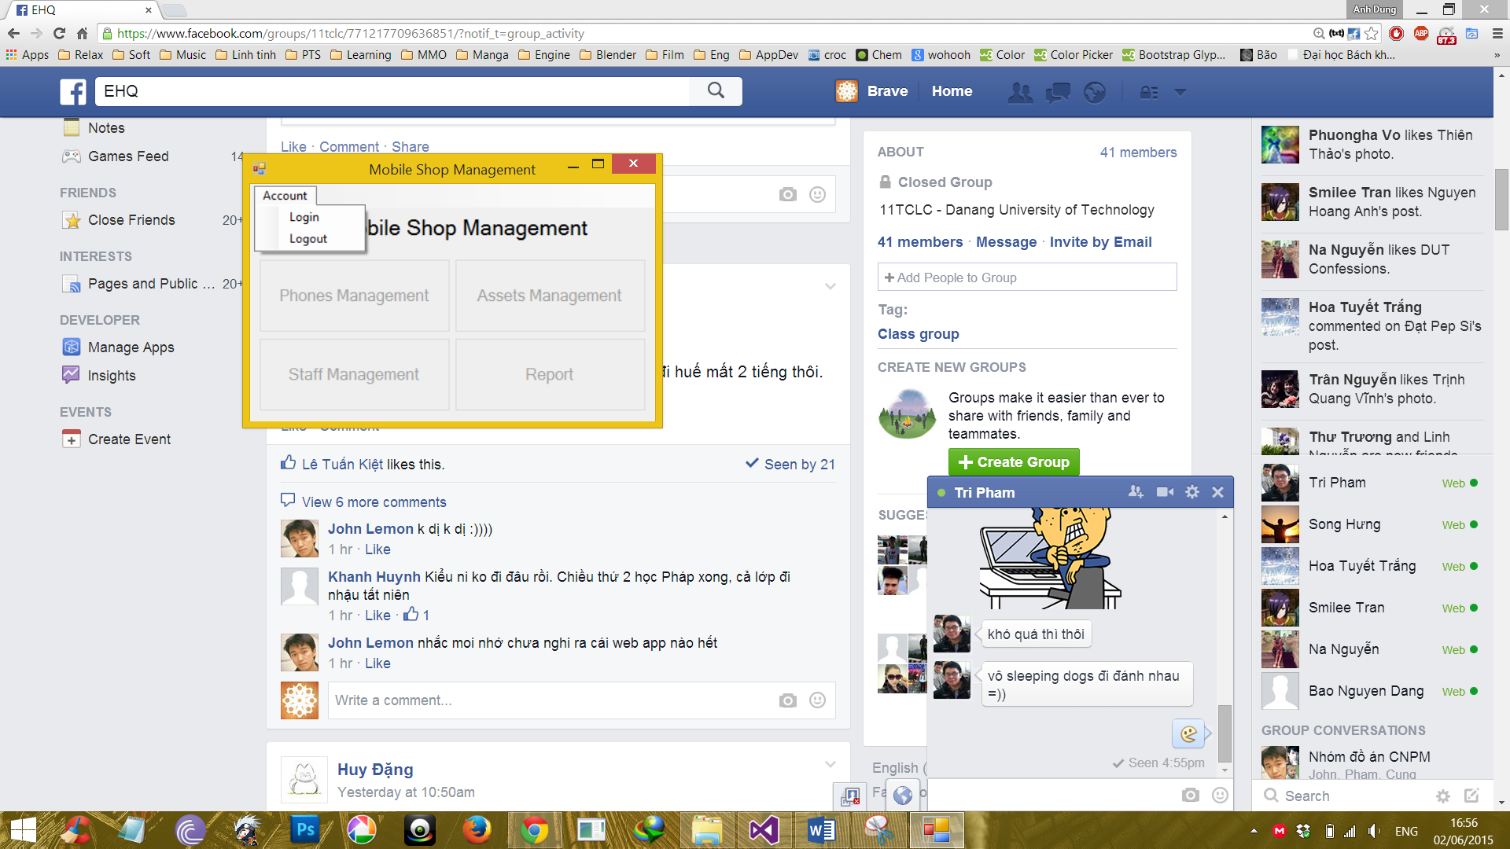

|  |  |  |  |  |  |
| --- | --- | --- | --- | --- | --- |
| **Screen** | Mobile Shop Management – User interface | | | | |
| **Description** | Display a screen where user can control the product. | | | |
| **Screen Access** | Users run program by click on file **MobileShopManagement.exe** | | | |
| **Screen Content** | | | | | |
| **Item** | **Type** | **Data** | **Description** | |
| Mobile Shop Management | Label |  | Name of the software | |
| Account | Menu strip item |  | Name of menu strip | |
| Log in | Menu strip item |  | Open a dialog where user can log into program | |
| Log out | Menu strip item |  | Log out the program. | |
| Products Management | Button |  | If user click on this button, the “Products Management” dialog will appear. | |
| Assets Management | Button |  | If user click on this button, the “Assets Management” dialog will appear. | |
| Staff Management | Button |  | If user click on this button, the “Staff Management” dialog will appear. | |
| Report | Button |  | If user click on this button, the “Report” dialog will appear. | |
| **Screen Actions** | | | | | |
| **Action Name** | **Description** | | **Success** | **Failure** |
| Log in | Everyone have an account and click on it to enter the system. | | Username of current user will display at the bottom of screen and all buttons will be enabled. | Displays message “Username or password is incorrect.” |
| Log out | Use to exit the system. | | Username of current user at the bottom of screen will be disappeared and all button will be disabled. | Nothing. |
| Phones Management | Go to Phones Management function. | | “Phones Management” dialog opened | Display a message “Database connection error”.  Display a message “Cannot open ‘Phones Management’ dialog”. |
| Assets Management | Go to Assets Management function. | | “Assets Management” dialog opened | Display a message “Database connection error”.  Display a message “Cannot open ‘Assets Management’ dialog”. |
| Staff Management | Go to Staff Management function. | | “Staff Management” dialog opened | Display a message “Database connection error”.  Display a message “Cannot open ‘Staff Management’ dialog”. |
| Report | Go to Report function. | | “Report” dialog opened | Display a message “Database connection error”.  Display a message “Cannot open ‘Report’ dialog”. |

## Phones Management:

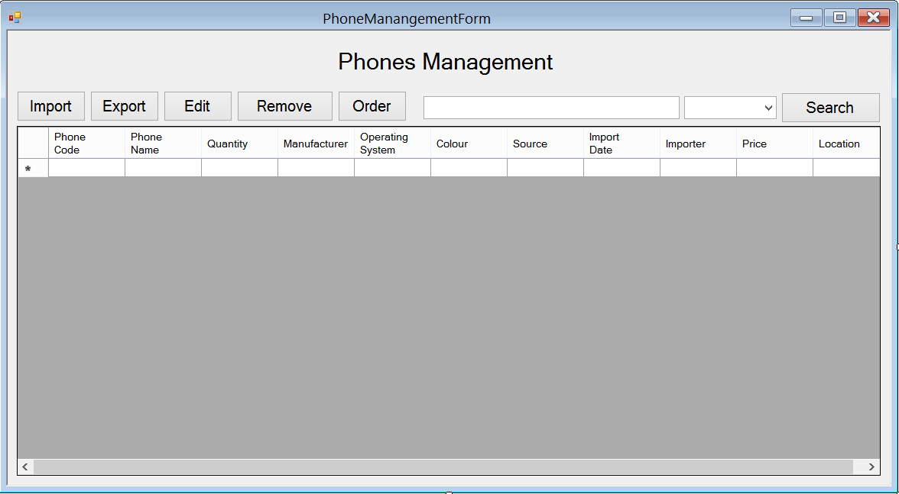

|  |  |  |  |  |  |
| --- | --- | --- | --- | --- | --- |
| **Screen** | Phones Management | | | | |
| **Description** | | Show information of phones, user can import new phones, export (sell) them, edit their information, remove them. In case they run out of some phones, they could order some more. | | | |
| **Screen Access** | | Users run program then click on **Phones Management** button | | | |
| **Screen Content** | | | | | |
| **Item** | | **Type** | **Data** | **Description** | |
| Data grid view | | Data grid view | Lookup all fields from PHONE table. | * Display all fields about the phone when the form loaded: phone code, phone name, quantity, manufacturer, operating system, colour, source, import date, importer, price, location. * This table is read-only, user cannot edit it. | |
| Import | | Button |  | User click on it to open “Import Phones” dialog and add new phones. | |
| Export | | Button |  | User click on it to open “Export Phones” dialog and add information of selling phone into database. | |
| Edit | | Button |  | User click on it to open “Edit Phones” and edit information of phone | |
| Remove | | Button |  | User click on it to remove the chosen phones in data grid view in case they stop selling them. | |
| Order | | Button |  | Open “Order Phones” dialog. When the store run out of some phones or some new phones that they don’t have, they could order their distributor to get them. | |
| Search | | Button |  | Search products by name, manufacturer, price | |
| Textbox | | Text field – String (50) |  | Enter the keyword that user want to search. | |
| Combo box | | Drop down list |  | User choose which field they want to search by: name, manufacturer and price. | |
| **Screen Actions** | | | | | |
| **Action Name** | | **Description** | | **Success** | **Failure** |
| Import | | Add information of new phones. | | “Import Phones” dialog opened. | Display a message “Cannot open ‘Import Phones’ dialog”. |
| Export | | Add information of selling phones. | | “Export Phones” dialog opened. | Display a message “Cannot open ‘Export Phones’ dialog”. |
| Edit | | Edit information of phones. | | “Edit Phones” dialog opened. | Display a message “Database connection error”.  Display a message “Cannot open ‘Edit Phones’ dialog”. |
| Remove | | Remove phones from database. | | Data grid view’s item removed. | Display a message “Cannot remove the chosen item”. |
| Order | | Make an order for new phones. | | “Order Phones” dialog opened. | Display a message “Cannot open ‘Order Phones’ dialog”. |
| Search | | Find a phone in the table below. | | Return the result of searching process. | Message “Not found”. |

### Phones Management – Import

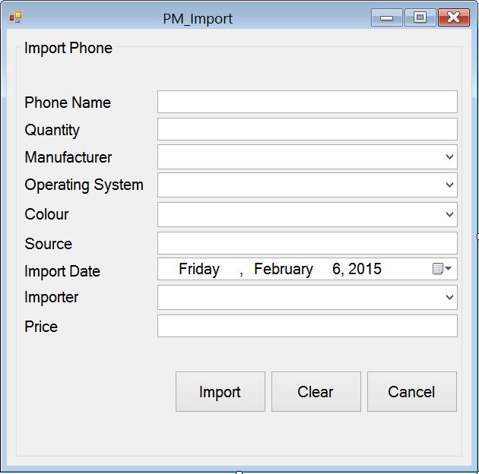

|  |  |  |  |  |  |
| --- | --- | --- | --- | --- | --- |
| **Screen** | Phones Management - Import | | | | |
| **Description** | Add new phone into data base | | | |
| **Screen Access** | Users run program by click on file **Phones Management -> Import** | | | |
| **Screen Content** | | | | | |
| **Item** | **Type** | **Data** | **Description** | |
| Import Phone | String (50) | Hard code | A title label. | |
| Phone Name | Text field – String (50) | Inserted into PHONE.NAME | This field is mandatory. The name of phone. | |
| Quantity | Text field – String (50) | Inserted into PRODUCT.QUANTITY | This field is mandatory and number-only. The quantity of phone | |
| Manufacturer | Dropdown list – String (50) | Lookup from table MANUFACTURER.NAME then input into PHONE.MANUFACTURER | This field is mandatory. The name of the manufacturer. | |
| Operating System | Dropdown list – String (50) | Lookup from table OPERATINGSYSTEM.NAME then input into PHONE.OPERATINGSYSTEM | This field is mandatory. The name of the Operating System | |
| Colour | Dropdown list – String (50) | Lookup from table COLOR.NAME then input into PHONE.COLOR | This field is mandatory. The colour of Phone | |
| Source | Text field – String (50) | Inserted into PHONE.SOURCE | Where the phone has been made. | |
| Import Date | Date time picker | Inserted into PHONE.IMPORTDATE | This field is mandatory. When the phone was imported. | |
| Importer | Dropdown list – String (50) | Lookup from table STAFF.NAME then input into PHONE.STAFF | This field is mandatory. Who import the phone. | |
| Price | Text field – String (50) | Inserted into PHONE.PRICE | This field is mandatory and number-only. The price of the phone | |
| Import | Button |  | Import new phone | |
| Clear | Button |  | Clear all the fields | |
| Cancel | Button |  | Cancel importing action | |
| **Screen Actions** | | | | | |
| **Action Name** | **Description** | | **Success** | **Failure** |
| Import | Import new phone | | Show a message to ask for confirmation.  Show message: “[Quantity] phone(s) has been imported”. | Display message: “Database connection error.”  Display message:  “Phone name must be entered.”  Display message:  “Quantity must be entered.”  Display message:  “Manufacturer must be chosen.”  Display message:  “Operating system must be chosen.”  Display message:  “Colour must be chosen.”  Display message:  “Import date must be chosen.”  Display message:  “Importer must be chosen.”  Display message:  “Price must be entered.” |
| Clear | Clear all the fields | | Set all the field to empty and all dropdown-list to default. | Nothing. |
| Cancel | Cancel importing action | | Show a message to ask if they wanted to close the form. | Nothing. |

### Phones Management – Export

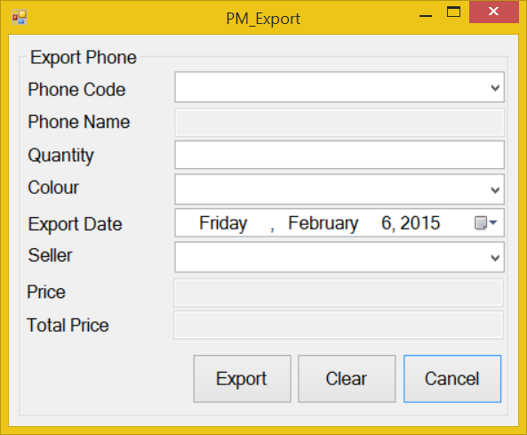

|  |  |  |  |  |  |
| --- | --- | --- | --- | --- | --- |
| **Screen** | Phones Management - Export | | | | |
| **Description** | Add information about selling phone | | | |
| **Screen Access** | Users run program by click on file **Phones Management -> Export** | | | |
| **Screen Content** | | | | | |
| **Item** | **Type** | **Data** | **Description** | |
| Export Phone | String (50) |  | Title | |
| Phone Code | Dropdown list – String (50) | Lookup from table PHONE.PRODUCTCODE | This field is mandatory. The code of the phone | |
| Phone Name | Text field – String (50) | Lookup from table PHONE.PRODUCTNAME | The name of the phone. This field is disabled and view-only, user cannot edit it. | |
| Quantity | Text field – String (50) | User input | This field is mandatory and number-only. The quantity of the phone | |
| Colour | Dropdown list – String (50) | Lookup from table COLOR.COLOR | This field is mandatory. The colour of the phone | |
| Export Date | Date time picker | User input | This field is mandatory. When the phone was exported? | |
| Seller | Dropdown list – String (50) | Lookup from table STAFF.CODE | This field is mandatory. Who sold the phone? | |
| Price | Text field – String (50) | Lookup from table PHONE.PRICE | The price of phone. This field is disabled and view-only, user cannot edit it. | |
| Total Price | Text field – String (50) | Price*Quantity | The total price of all phone have been sold. This field is disabled and view-only, user cannot edit it. | |
| Export | Button |  | Export information about selling phone. | |
| Clear | Button |  | Clear all the fields | |
| Cancel | Button |  | Close Export form | |
| **Screen Actions** | | | | | |
| **Action Name** | **Description** | | **Success** | **Failure** |
| Export | Export information about selling phone. | | Show a message to ask for confirmation.  Show message: “[Quantity] phone(s) has been exported”. | Display message: “Database connection error.”  Display message:  “Phone code must be chosen.”  Display message:  “Quantity must be entered.”  Display message:  “Colour must be chosen.”  Display message:  “Export date must be chosen.”  Display message:  “Seller must be chosen.” |
| Clear | Clear all the fields | | Set all the field to empty and all dropdown-list to default. | Nothing |
| Cancel | Close Export form | | Show a message to ask if they wanted to close the field. | Nothing |

### Phones Management – Edit

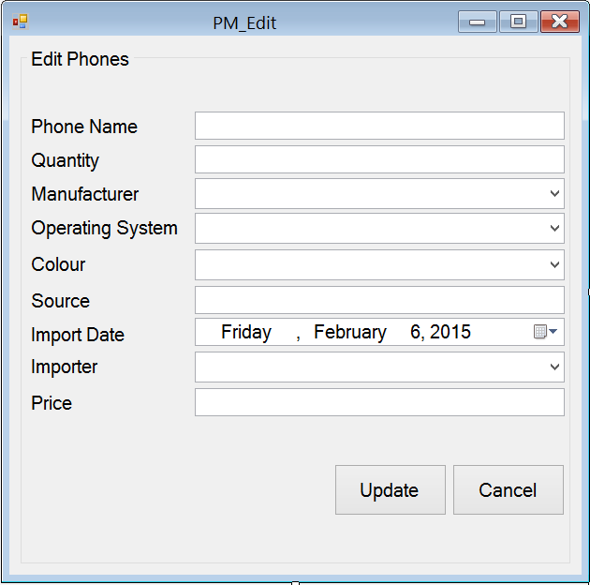

|  |  |  |  |  |  |
| --- | --- | --- | --- | --- | --- |
| **Screen** | Product Management - Edit | | | | |
| **Description** | Edit information of product | | | |
| **Screen Access** | Users run program by click on file **Product Management -> Edit** | | | |
| **Screen Content** | | | | | |
| **Item** | **Type** | **Data** | **Description** | |
| Edit Phones | String (50) |  | Title | |
| Phone Name | Text field – String (50) | Lookup from table PHONE.NAME | This field is mandatory. The name of phone. | |
| Quantity | Text field – String (50) | Lookup from table PHONE.QUANTITY | This field is mandatory and number-only. The quantity of phone | |
| Manufacturer | Dropdown list – String (50) | Lookup from table PHONE.MANUFACTURER | This field is mandatory. The name of the manufacturer. | |
| Operating System | Dropdown list – String (50) | Lookup from table OPERATINGSYSTEM.NAME | This field is mandatory. The name of the Operating System | |
| Colour | Dropdown list – String (50) | Lookup from table COLOR.NAME | This field is mandatory. The colour of Phone | |
| Source | Text field – String (50) | Lookup from table PHONE.SOURCE | Where the phone has been made. | |
| Import Date | Date time picker | Lookup from table PHONE.IMPORTDATE | This field is mandatory. When the phone was imported. | |
| Importer | Dropdown list – String (50) | STAFF.CODE | This field is mandatory. Who import the phone. | |
| Price | Text field – String (50) | Table PHONE.PRICE | This field is mandatory and number-only. The price of the phone | |
| Update | Button |  | Click to update the information | |
| Cancel | Button |  | Click to close the form | |
| **Screen Actions** | | | | | |
| **Action Name** | **Description** | | **Success** | **Failure** |
| Update | Update phone information | | Show a message to notice: “Phone’s information has been updated”. | Display message: “Database connection error.”  Display message:  “Phone name must be entered.”  Display message:  “Quantity must be entered.”  Display message:  “Source must be entered.”  Display message:  “Import date must be chosen.”  Display message:  “Price must be entered.” |
| Cancel | Close the form | | Show a message to ask if they wanted to close the form. | Nothing |

### Phones Management – Order

#### Order – Order Phones

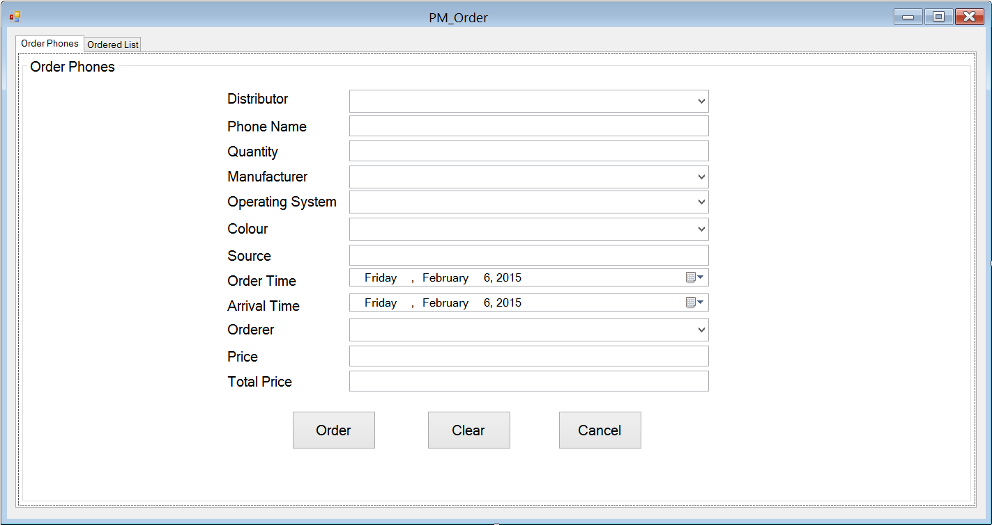

|  |  |  |  |  |  |
| --- | --- | --- | --- | --- | --- |
| **Screen** | Phones Management – Order – Order Phones | | | | |
| **Description** | Order the distributor new phones in case they run out of phones | | | |
| **Screen Access** | Users run program by click on file **Phones Management -> Order -> Order Phones** | | | |
| **Screen Content** | | | | | |
| **Item** | **Type** | **Data** | **Description** | |
| Order Phones | Tab |  | Tab title | |
| Order Phones | String (50) |  | Title | |
| Distributor | Dropdown list – String (50) | Lookup from DISTRIBUTOR.NAME then input into ORDER.DISTRIBUTOR | This field is mandatory. Who distribute the phones | |
| Phone Name | Text field – String (50) | Inserted into ORDER.PRODUCTNAME | This field is mandatory. The name of the phone | |
| Quantity | Text field – String (50) | Inserted into ORDER.PRODUCTQUANTITY | This field is mandatory. The quantity of the phone | |
| Manufacturer | Dropdown list – String (50) | Lookup from table MANUFACTURER.NAME then input into ORDER.MANUFACTURER | This field is mandatory. The manufacturer of the phone | |
| Operating System | Dropdown list – String (50) | Lookup from table OPERATINGSYSTEM.NAME then input into ORDER.OPERATINGSYSTEM | This field is mandatory. The operating system of the phone | |
| Colour | Dropdown list – String (50) | Lookup from table COLOR.NAME then input into ORDER.PRODUCTCOLOR | This field is mandatory. The colour of the phone | |
| Source | Text field – String (50) | Inserted into ORDER.SOURCE | Where the phone has been made | |
| Order Time | Date time picker | Inserted into ORDER.ORDERTIME | This field is mandatory. When did they ordered them | |
| Arrival Time | Date time picker | Inserted into ORDER.ARRIVALTIME | This field is mandatory. When will the phone arrive | |
| Orderer | Dropdown list – String (50) | Inserted into ORDER.ORDERER | This field is mandatory. Who ordered this phone | |
| Price | Text field – String (50) | Inserted into ORDER.PRICE | This field is mandatory. The price of the phone | |
| Total Price | Text field – String (50) | Price*Quantity. | This field is read-only, user cannot edit it. The total price of all the phones has been ordered | |
| Order | Button |  | Add to database | |
| Clear | Button |  | Clear all the fields | |
| Cancel | Button |  | Close the form | |
| **Screen Actions** | | | | | |
| **Action Name** | **Description** | | **Success** | **Failure** |
| Order | Add to database | | Show a message to notice: “An order has been added”. | Display message: “Database connection error.”  Display message:  “Distributor must be chosen.”  Display message:  “Phone name must be entered.”  Display message:  “Quantity must be entered.”  Display message:  “Manufacturer must be chosen.”  Display message:  “Operating system must be chosen.”  Display message:  “Colour must be chosen.”  Display message:  “Source must be entered.”  Display message:  “Order time must be chosen.”  Display message:  “Arrival time must be chosen.”  Display message:  “Orderer must be entered.”  Display message:  “Price must be entered.” |
| Clear | Clear all the fields | | Set all the field to empty and all dropdown-list to default. | Nothing. |
| Cancel | Close the form | | Show a message to ask if they wanted to close the form. | Nothing. |

#### Order – Ordered List

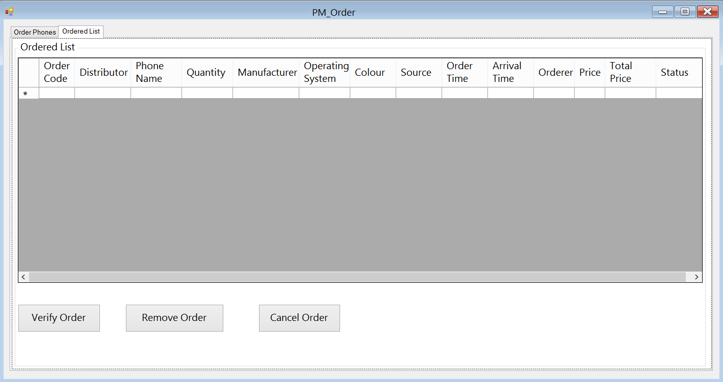

|  |  |  |  |  |  |
| --- | --- | --- | --- | --- | --- |
| **Screen** | Phones Management – Order – Ordered List | | | | |
| **Description** | | Display the orders has been added to the database. | | | |
| **Screen Access** | | Users run program then click on **Phones Management -> Order -> Ordered List** | | | |
| **Screen Content** | | | | | |
| **Item** | | **Type** | **Data** | **Description** | |
| Ordered List | | Tab |  | Tab title | |
| Ordered List | | String (50) |  | Title | |
| Data grid view | | Data grid view | Lookup all fields from ORDER table. | * Display all fields about the ordered list when the form loaded: Distributor, product name, quantity, manufacturer, operating system, colour, source, order time, arrival time, ordered, price, total price, status. * This table is read-only, user cannot edit it. | |
| Verify Order | | Button |  | User choose an order from the table above and click on this button to verify the order has been arrived. | |
| Remove Order | | Button |  | User choose an order from the table above and click on this button to remove the arrival order. | |
| Cancel Order | | Button |  | User choose an order from the table above and click on this button to cancel the pending order. | |
| **Screen Actions** | | | | | |
| **Action Name** | | **Description** | | **Success** | **Failure** |
| Verify Order | | Verify an order | | Show a message to confirm. | Show a message: “Please choose an order to verify”. |
| Remove Order | | Remove an order | | Show a message to confirm. | Show a message: “Please choose an order to remove”. |
| Cancel Order | | Cancel an order | | Show a message to confirm. | Show a message: “Please choose an order to cancel”. |

## Assets Management:

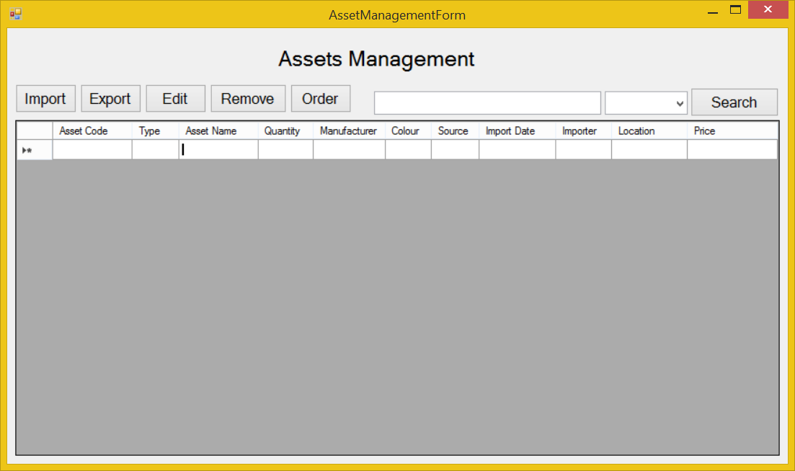

|  |  |  |  |  |  |
| --- | --- | --- | --- | --- | --- |
| **Screen** | Assets Management | | | | |
| **Description** | | Show information of assets, user can import new assets, export (sell) them, edit their information, remove them. In case they run out of some assets, they could order some more. | | | |
| **Screen Access** | | Users run program then click on **Assets Management** button | | | |
| **Screen Content** | | | | | |
| **Item** | | **Type** | **Data** | **Description** | |
| Data grid view | | Data grid view | Lookup all fields from ASSET table. | * Display all fields about the asset when the form loaded: asset code, type, asset name, quantity, manufacturer, colour, source, import date, importer, price * This table is read-only, user cannot edit it. | |
| Import | | Button |  | User click on it to open “Import Assets” dialog and add new assets. | |
| Export | | Button |  | User click on it to open “Export Assets” dialog and add information of selling asset into database. | |
| Edit | | Button |  | User click on it to open “Edit Assets” and edit information of asset | |
| Remove | | Button |  | User click on it to remove the chosen asset in data grid view in case they stop selling them. | |
| Order | | Button |  | Open “Order Assets” dialog. When the store run out of some phones or some new assets that they don’t have, they could order their distributor to get them. | |
| Search | | Button |  | Search assets by name, manufacturer, price | |
| Textbox | | Text field – String (50) |  | Enter the keyword that user want to search. | |
| Combo box | | Drop down list |  | User choose which field they want to search by: name, manufacturer and price. | |
| **Screen Actions** | | | | | |
| **Action Name** | | **Description** | | **Success** | **Failure** |
| Import | | Add information of new assets. | | “Import Assets” dialog opened. | Display a message “Cannot open ‘Import Assets’ dialog”. |
| Export | | Add information of selling assets. | | “Export Assets” dialog opened. | Display a message “Cannot open ‘Export Assets’ dialog”. |
| Edit | | Edit information of assets. | | “Edit Assets” dialog opened. | Display a message “Database connection error”.  Display a message “Cannot open ‘Edit Assets’ dialog”. |
| Remove | | Remove assets from database. | | Data grid view’s item removed. | Display a message “Cannot remove the chosen item”. |
| Order | | Make an order for new assets. | | “Order Assets” dialog opened. | Display a message “Cannot open ‘Order Assets’ dialog”. |
| Search | | Find a asset in the table below. | | Return the result of searching process. | Message “Not found”. |

### Assets Management – Import

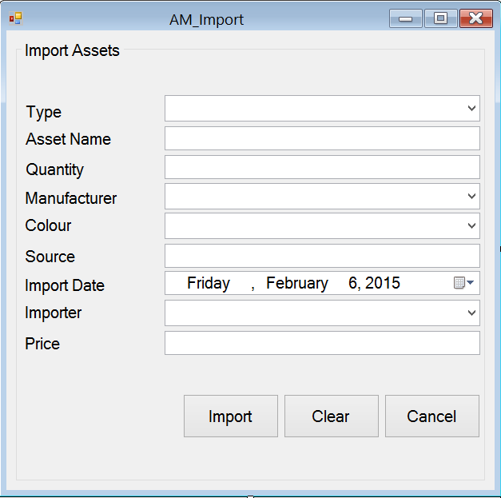

|  |  |  |  |  |  |
| --- | --- | --- | --- | --- | --- |
| **Screen** | Assets Management - Import | | | | |
| **Description** | Add new assets into data base | | | |
| **Screen Access** | Users run program by click on file **Assets Management -> Import** | | | |
| **Screen Content** | | | | | |
| **Item** | **Type** | **Data** | **Description** | |
| Import Phone | String (50) | Hard code | A title label. | |
| Type | Dropdown list – String (50) | Lookup from table ASSET.TYPE | This field is mandatory. Type of assets. | |
| Asset Name | Text field – String (50) | Inserted into ASSET.NAME | This field is mandatory. The name of asset. | |
| Quantity | Text field – String (50) | Inserted into ASSET.QUANTITY | This field is mandatory and number-only. The quantity of asset | |
| Manufacturer | Dropdown list – String (50) | Lookup from table MANUFACTURER.NAME then input into ASSET.MANUFACTURER | This field is mandatory. The name of the manufacturer. | |
| Colour | Dropdown list – String (50) | Lookup from table COLOR.NAME then input into ASSET.COLOR | This field is mandatory. The colour of asset | |
| Source | Text field – String (50) | Inserted into ASSET.SOURCE | Where the asset has been made. | |
| Import Date | Date time picker | Inserted into ASSET.IMPORTDATE | This field is mandatory. When the asset was imported. | |
| Importer | Dropdown list – String (50) | Lookup from table STAFF.NAME then input into ASSET.STAFF | This field is mandatory. Who import the asset | |
| Price | Text field – String (50) | Inserted into ASSET.PRICE | This field is mandatory and number-only. The price of the asset | |
| Import | Button |  | Import new asset | |
| Clear | Button |  | Clear all the fields | |
| Cancel | Button |  | Cancel importing action | |
| **Screen Actions** | | | | | |
| **Action Name** | **Description** | | **Success** | **Failure** |
| Import | Import new asset | | Show a message to ask for confirmation.  Show message: “[Quantity] asset (s) has been imported”. | Display message: “Database connection error.”  Display message:  “Type must be chosen.”  Display message:  “Asset name must be entered.”  Display message:  “Quantity must be entered.”  Display message:  “Manufacturer must be chosen.”  Display message:  “Colour must be chosen.”  Display message:  “Import date must be chosen.”  Display message:  “Importer must be chosen.”  Display message:  “Price must be entered.” |
| Clear | Clear all the fields | | Set all the field to empty and all dropdown-list to default. | Nothing. |
| Cancel | Cancel importing action | | Show a message to ask if they wanted to close the form. | Nothing. |

### Assets Management – Export

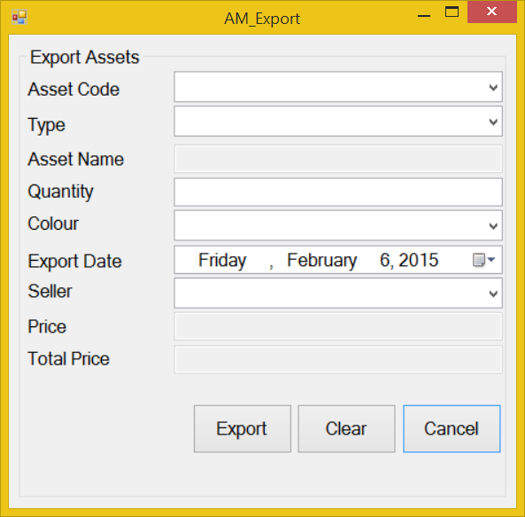

|  |  |  |  |  |  |
| --- | --- | --- | --- | --- | --- |
| **Screen** | Assets Management - Export | | | | |
| **Description** | Add information about selling asset | | | |
| **Screen Access** | Users run program by click on file **Assets Management -> Export** | | | |
| **Screen Content** | | | | | |
| **Item** | **Type** | **Data** | **Description** | |
| Export Asset | String (50) |  | Title | |
| Asset Code | Dropdown list – String (50) | Lookup from table PHONE.PRODUCTCODE | This field is mandatory. The code of the phone | |
| Type | Dropdown list – String (50) | Lookup from table ASSET.TYPE | This field is mandatory. Type of asset | |
| Asset Name | Text field – String (50) | Lookup from table ASSET.PRODUCTNAME | The name of the asset. This field is disabled and view-only, user cannot edit it. | |
| Quantity | Text field – String (50) | User input. Inserted into ASSET.QUANTITY | This field is mandatory and number-only. The quantity of the asset | |
| Colour | Dropdown list – String (50) | Lookup from table COLOR.NAME | This field is mandatory. The colour of the asset | |
| Export Date | Date time picker | User input | This field is mandatory. When the asset was exported? | |
| Seller | Dropdown list – String (50) | Lookup from table STAFF.CODE | This field is mandatory. Who sold the asset? | |
| Price | Text field – String (50) | Lookup from table ASSET.PRICE | The price of asset. This field is disabled and view-only, user cannot edit it. | |
| Total Price | Text field – String (50) | Price*Quantity | The total price of all asset have been sold. This field is disabled and view-only, user cannot edit it. | |
| Export | Button |  | Export information about selling asset. | |
| Clear | Button |  | Clear all the fields | |
| Cancel | Button |  | Close Export form | |
| **Screen Actions** | | | | | |
| **Action Name** | **Description** | | **Success** | **Failure** |
| Export | Export information about selling asset. | | Show a message to ask for confirmation.  Show message: “[Quantity] asset (s) has been exported”. | Display message: “Database connection error.”  Display message:  “Asset code must be chosen.”  Display message:  “Type must be chosen.”  Display message:  “Quantity must be entered.”  Display message:  “Colour must be chosen.”  Display message:  “Export date must be chosen.”  Display message:  “Seller must be chosen.” |
| Clear | Clear all the fields | | Set all the field to empty and all dropdown-list to default. | Nothing |
| Cancel | Close Export form | | Show a message to ask if they wanted to close the field. | Nothing |

### Assets Management – Edit

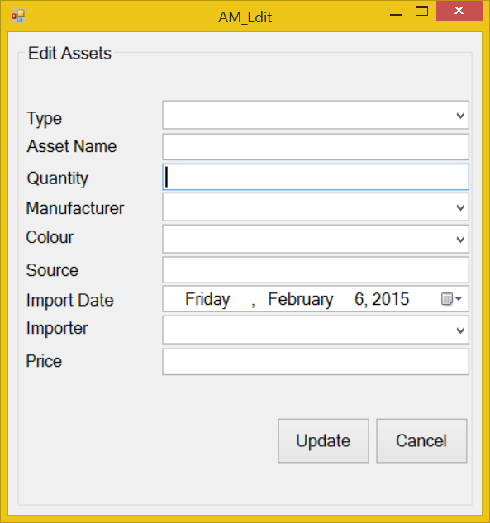

|  |  |  |  |  |  |
| --- | --- | --- | --- | --- | --- |
| **Screen** | Asset Management - Edit | | | | |
| **Description** | Edit information of asset | | | |
| **Screen Access** | Users run program by click on file **Asset Management -> Edit** | | | |
| **Screen Content** | | | | | |
| **Item** | **Type** | **Data** | **Description** | |
| Edit Assets | String (50) |  | Title | |
| Type | Dropdown list – String (50) | Lookup from table ASSET.TYPE | This field is mandatory. The type of asset. | |
| Asset Name | Text field – String (50) | Lookup from table ASSET.NAME | This field is mandatory. The name of asset. | |
| Quantity | Text field – String (50) | Lookup from table ASSET.QUANTITY | This field is mandatory and number-only. The quantity of asset | |
| Manufacturer | Dropdown list – String (50) | Lookup from table ASSET .MANUFACTURER | This field is mandatory. The name of the manufacturer. | |
| Colour | Dropdown list – String (50) | Lookup from table COLOR.NAME | This field is mandatory. The colour of asset | |
| Source | Text field – String (50) | Lookup from table ASSET.SOURCE | Where the asset has been made. | |
| Import Date | Date time picker | Lookup from table ASSET.IMPORTDATE | This field is mandatory. When the asset was imported. | |
| Importer | Dropdown list – String (50) | STAFF.CODE | This field is mandatory. Who import the asset | |
| Price | Text field – String (50) | Table ASSET.PRICE | This field is mandatory and number-only. The price of the asset | |
| Update | Button |  | Click to update the information | |
| Cancel | Button |  | Click to close the form | |
| **Screen Actions** | | | | | |
| **Action Name** | **Description** | | **Success** | **Failure** |
| Update | Update asset information | | Show a message to notice: “Asset’s information has been updated”. | Display message: “Database connection error.”  Display message:  “Asset name must be entered.”  Display message:  “Quantity must be entered.”  Display message:  “Source must be entered.”  Display message:  “Import date must be chosen.”  Display message:  “Price must be entered.” |
| Cancel | Close the form | | Show a message to ask if they wanted to close the form. | Nothing |

### Assets Management – Order

#### Order – Order Products

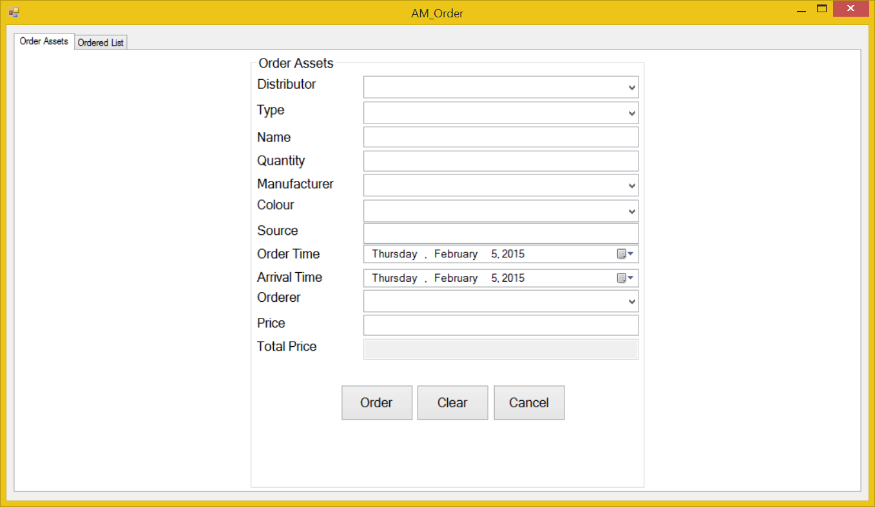

|  |  |  |  |  |  |
| --- | --- | --- | --- | --- | --- |
| **Screen** | Assets Management – Order – Order Assets | | | | |
| **Description** | Order the distributor new Assets in case they run out of Assets | | | |
| **Screen Access** | Users run program by click on file **Assets Management -> Order -> Order Assets** | | | |
| **Screen Content** | | | | | |
| **Item** | **Type** | **Data** | **Description** | |
| Order Assets | Tab |  | Tab title | |
| Order Assets | String (50) |  | Title | |
| Distributor | Dropdown list – String (50) | Lookup from DISTRIBUTOR.NAME then input into ORDER.DISTRIBUTOR | This field is mandatory. Who distribute the assets | |
| Type | Dropdown list – String (50) | Lookup from table ASSET.TYPE | This field is mandatory. The type of asset. | |
| Asset Name | Text field – String (50) | Inserted into ORDER.PRODUCTNAME | This field is mandatory. The name of the assets | |
| Quantity | Text field – String (50) | Inserted into ORDER.PRODUCTQUANTITY | This field is mandatory. The quantity of the assets | |
| Manufacturer | Dropdown list – String (50) | Lookup from table MANUFACTURER.NAME then input into ORDER.MANUFACTURER | This field is mandatory. The manufacturer of the assets | |
| Colour | Dropdown list – String (50) | Lookup from table COLOR.NAME then input into ORDER.PRODUCTCOLOR | This field is mandatory. The colour of the assets | |
| Source | Text field – String (50) | Inserted into ORDER.SOURCE | Where the phone has been made | |
| Order Time | Date time picker | Inserted into ORDER.ORDERTIME | This field is mandatory. When did they ordered them | |
| Arrival Time | Date time picker | Inserted into ORDER.ARRIVALTIME | This field is mandatory. When will the assets arrive | |
| Orderer | Dropdown list – String (50) | Inserted into ORDER.ORDERER | This field is mandatory. Who ordered this assets | |
| Price | Text field – String (50) | Inserted into ORDER.PRICE | This field is mandatory. The price of the assets | |
| Total Price | Text field – String (50) | Price*Quantity. | This field is read-only, user cannot edit it. The total price of all the assets has been ordered | |
| Order | Button |  | Add to database | |
| Clear | Button |  | Clear all the fields | |
| Cancel | Button |  | Close the form | |
| **Screen Actions** | | | | | |
| **Action Name** | **Description** | | **Success** | **Failure** |
| Order | Add to database | | Show a message to notice: “An order has been added”. | Display message: “Database connection error.”  Display message:  “Distributor must be chosen.”  Display message:  “Type must be chosen.”  Display message:  “Asset name must be entered.”  Display message:  “Quantity must be entered.”  Display message:  “Manufacturer must be chosen.”  Display message:  “Colour must be chosen.”  Display message:  “Source must be entered.”  Display message:  “Order time must be chosen.”  Display message:  “Arrival time must be chosen.”  Display message:  “Orderer must be entered.”  Display message:  “Price must be entered.” |
| Clear | Clear all the fields | | Set all the field to empty and all dropdown-list to default. | Nothing. |
| Cancel | Close the form | | Show a message to ask if they wanted to close the form. | Nothing. |

#### Order – Ordered List

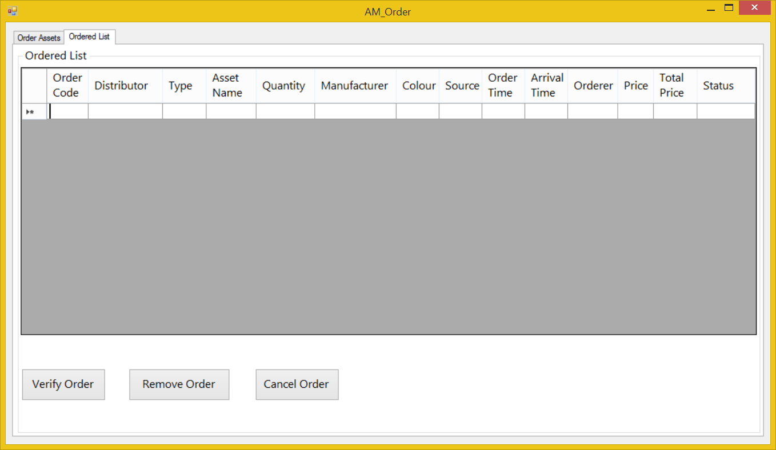

|  |  |  |  |  |  |
| --- | --- | --- | --- | --- | --- |
| **Screen** | Assets Management – Order – Ordered List | | | | |
| **Description** | | Display the orders has been added to the database. | | | |
| **Screen Access** | | Users run program then click on **Assets Management -> Order -> Ordered List** | | | |
| **Screen Content** | | | | | |
| **Item** | | **Type** | **Data** | **Description** | |
| Ordered List | | Tab |  | Tab title | |
| Ordered List | | String (50) |  | Title | |
| Data grid view | | Data grid view | Lookup all fields from ORDER table. | * Display all fields about the ordered list when the form loaded: Distributor, type, asset name, quantity, manufacturer, colour, source, order time, arrival time, ordered, price, total price, status. * This table is read-only, user cannot edit it. | |
| Verify Order | | Button |  | User choose an order from the table above and click on this button to verify the order has been arrived. | |
| Remove Order | | Button |  | User choose an order from the table above and click on this button to remove the arrival order. | |
| Cancel Order | | Button |  | User choose an order from the table above and click on this button to cancel the pending order. | |
| **Screen Actions** | | | | | |
| **Action Name** | | **Description** | | **Success** | **Failure** |
| Verify Order | | Verify an order | | Show a message to confirm. | Show a message: “Please choose an order to verify”. |
| Remove Order | | Remove an order | | Show a message to confirm. | Show a message: “Please choose an order to remove”. |
| Cancel Order | | Cancel an order | | Show a message to confirm. | Show a message: “Please choose an order to cancel”. |

## Staff Management

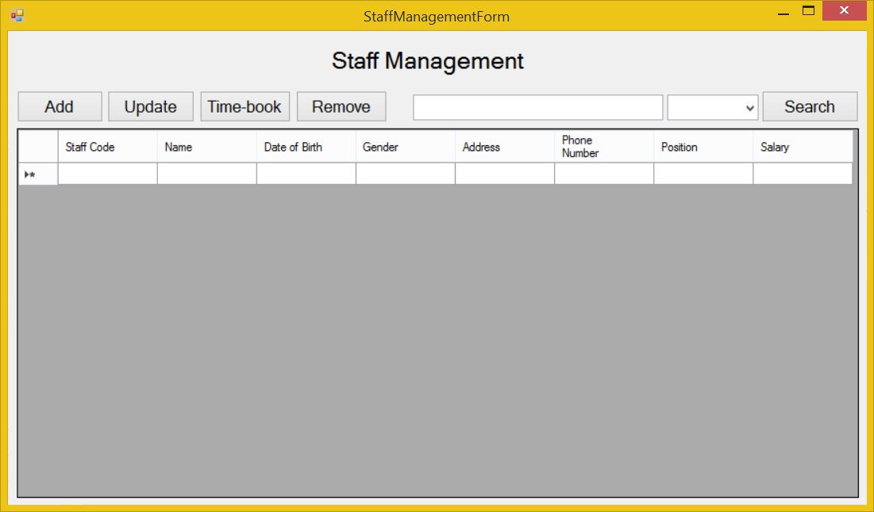

|  |  |  |  |  |  |
| --- | --- | --- | --- | --- | --- |
| **Screen** | Staff Management | | | | |
| **Description** | | Display a screen where user can manage their staff. | | | |
| **Screen Access** | | Users run program then click on **Staff Management** button. | | | |
| **Screen Content** | | | | | |
| **Item** | | **Type** | **Data** | **Description** | |
| Data grid view | | Data grid view | Lookup all fields from STAFF table. | * Display all fields about the staff when the form loaded: staff code, name, date of birth, gender, address, phone number, position and salary. * This table is read-only, user cannot edit it. | |
| Add | | Button |  | Open “Add Staff” dialog when user click it. | |
| Update | | Button |  | Open “Update Staff” dialog when user choose an item from data grid view and click this button. | |
| Time-book | | Button |  | Open “Time-book” dialog when user click it. | |
| Remove | | Button |  | Remove a staff when user choose an item from data grid view and click this button. | |
| Search | | Button |  | User click on it to search | |
| Textbox | | Text field – String (50) |  | User type their keyword to search | |
| Combo box | | Drop down list |  | Filter searching result by: Name | |
| **Screen Actions** | | | | | |
| **Action Name** | | **Description** | | **Success** | **Failure** |
| Add | | Open “Add Staff” dialog | | “Add Staff” dialog opened | Display a message “Cannot open ‘Add Staff’ dialog”. |
| Update | | Open “Update Staff” dialog | | “Update Staff” dialog opened | Display a message “Cannot open ‘Update Staff’ dialog”. |
| Time-book | | Open “Time-book” dialog | | “Time-book” dialog opened | Display a message “Cannot open ‘Time-book’ dialog”. |
| Remove | | Remove a staff | | Data grid view’s item removed. | Display a message “Cannot remove the chosen item”. |
| Search | | Find a product in the table below. | | Return the result of searching process | Display a message “Not found”. |

### Staff Management – Add

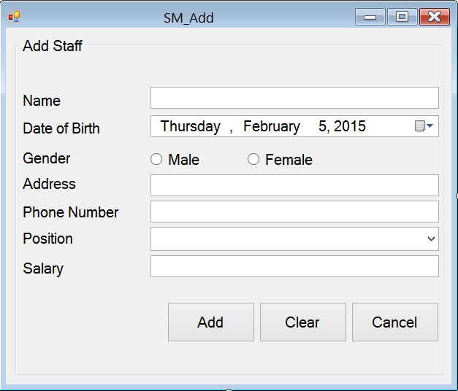

|  |  |  |  |  |  |
| --- | --- | --- | --- | --- | --- |
| **Screen** | Staff Management – Add Staff | | | | |
| **Description** | Allow Administrator and Managers Account to add new staff members. | | | |
| **Screen Access** | Users run program by click on file **Staff Management -> Add** | | | |
| **Screen Content** | | | | | |
| **Item** | **Type** | **Data** | **Description** | |
| Add Staff | String (50) |  | Name of the form | |
| Name | Text field – String (50) | Inserted into STAFF.NAME | This field is mandatory.  Name of staff member. | |
| Date of birth | Date time picker | Inserted into STAFF.DOB | User pick the date from a date time picker | |
| Gender - Male | Radio button | Inserted into STAFF.GENDER | This field is mandatory.  Gender of staff member (male) | |
| Gender - female | Radio button | Inserted into STAFF.GENDER | This field is mandatory.  Gender of staff member (female) | |
| Address | Text field – String (50) | Inserted into STAFF.ADDRESS | Address of staff member. This field is optional. | |
| Phone number | Text field – String (50) | Inserted into STAFF.PHONENUMBER | This field is mandatory and number only. Managers need staff member’s phone number to contact. | |
| Position | Dropdown list – String (50) | Inserted into STAFF.POSITION | This field is mandatory. Choose from the available position in the dropdown list. | |
| Salary | Text field – String (50) | Inserted into STAFF.SALARY | This field is mandatory and number only. | |
| Add | Button |  | Add data into database | |
| Clear | Button |  | Clear all inserted data | |
| Cancel | Button |  | Cancel “Add Staff”. | |
| **Screen Actions** | | | | | |
| **Action Name** | **Description** | | **Success** | **Failure** |
| Add | Inserted data will be saved into the DB. | | Display a message “A staff member has been added”.  Back to the “Staff Management” screen with new record on the table below (default list with all data).  When go back to the list from “Staff Management” screen, the new record will be focused on. | Display message: “Database connection error.”  Display message:  “Name must be entered.”  Display message:  “Gender must be chosen.”  Display message:  “Phone number must be entered.”  Display message:  “Position must be chosen.”  Display message:  “Salary number must be entered.” |
| Clear | Clear inserted data. | | All field cleared. | Nothing. |
| Cancel | Close “Add Staff” dialog. | | “Add Staff” dialog closed. | Nothing. |

### Staff Management – Update

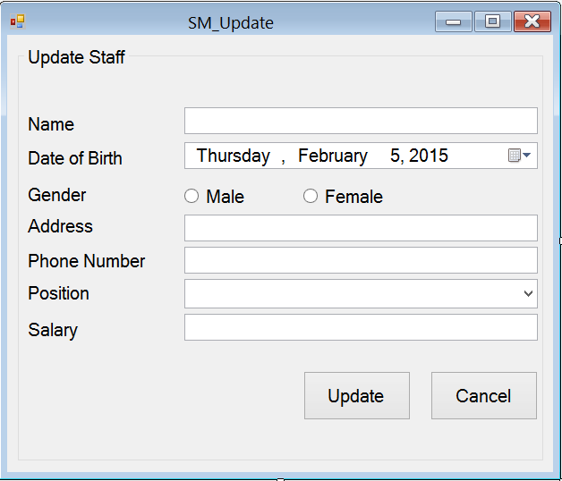

|  |  |  |  |  |  |
| --- | --- | --- | --- | --- | --- |
| **Screen** | Staff Management – Update Staff | | | | |
| **Description** | Allow Administrator and Managers Account to update existing staff members. | | | |
| **Screen Access** | Users run program by click on file **Staff Management -> Update** | | | |
| **Screen Content** | | | | | |
| **Item** | **Type** | **Data** | **Description** | |
| Update Staff | String (50) |  | Name of the form | |
| Name | Text field – String (50) | Look up from STAFF.NAME | This field is mandatory.  Name of staff member. | |
| Date of birth | Date time picker | Look up from STAFF.DOB | User pick the date from a date time picker | |
| Gender - Male | Radio button | Look up from STAFF.GENDER | This field is mandatory.  Gender of staff member (male) | |
| Gender - female | Radio button | Look up from STAFF.GENDER | This field is mandatory.  Gender of staff member (female) | |
| Address | Text field – String (50) | Look up from STAFF.ADDRESS | Address of staff member. This field is optional. | |
| Phone number | Text field – String (50) | Look up from STAFF.PHONENUMBER | This field is mandatory and number only. Managers need staff member’s phone number to contact. | |
| Position | Dropdown list – String (50) | Look up from STAFF.POSITION | This field is mandatory. Choose from the available position in the dropdown list. | |
| Salary | Text field – String (50) | Look up from STAFF.SALARY | This field is mandatory and number only. | |
| Add | Button |  | Add data into database | |
| Cancel | Button |  | Cancel “Add Staff”. | |
| **Screen Actions** | | | | | |
| **Action Name** | **Description** | | **Success** | **Failure** |
| Update | Inserted data will be saved into the DB. | | Display a message “A staff member has been updated”.  Back to the “Staff Management” screen with new record on the table below (default list with all data).  When go back to the list from “Staff Management” screen, the new record will be focused on. | Display message: “Database connection error.”  Display message:  “Name must be entered.”  Display message:  “Phone number must be entered.”  Display message:  “Position must be chosen.”  Display message:  “Salary number must be entered.” |
| Cancel | Close “Update Staff” dialog. | | “Update Staff” dialog closed. | Nothing. |

### Staff Management – Time-book

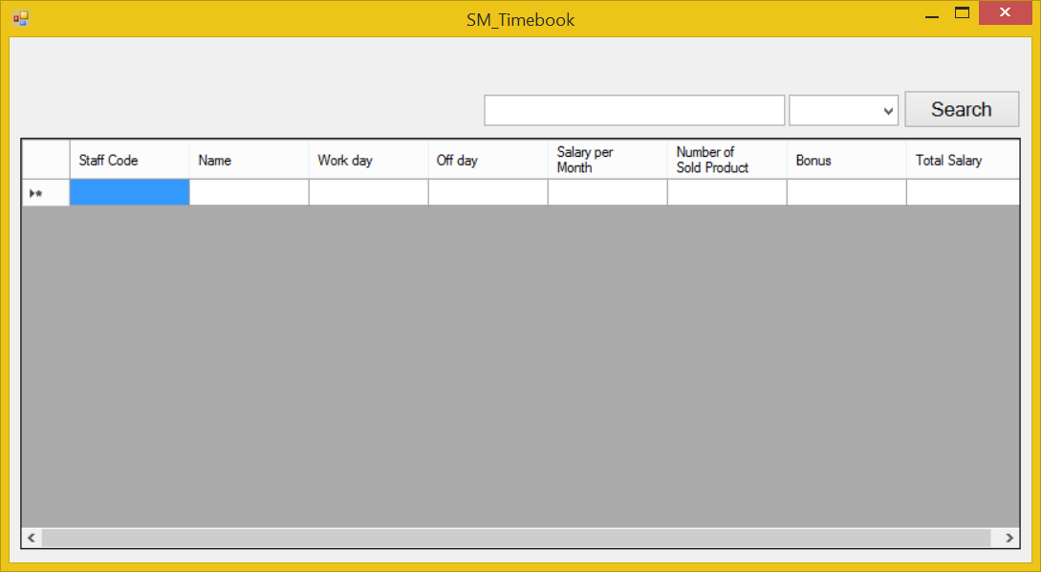

|  |  |  |  |  |  |
| --- | --- | --- | --- | --- | --- |
| **Screen** | Staff Management – Time-book. | | | | |
| **Description** | | Display a screen where user can manage staff member’s jobs. | | | |
| **Screen Access** | | Users run program then click on **Staff Management -> Time-book** | | | |
| **Screen Content** | | | | | |
| **Item** | | **Type** | **Data** | **Description** | |
| Data grid view | | Data grid view | Lookup all fields from TIMEBOOK table. | * Display all fields about the staff’s time-book when the form loaded: staff code, name, work day, off day, salary per month, number of product sold, bonus, total salary. * This table is read-only, user cannot edit it. | |
| Search | | Button |  | User click on it to search | |
| Textbox | | Text field – String (50) |  | User type their keyword to search | |
| Combo box | | Drop down list |  | Filter searching result by: Name | |
| **Screen Actions** | | | | | |
| **Action Name** | | **Description** | | **Success** | **Failure** |
| Search | | Find a product in the table below. | | Return the result of searching process | Display a message “Not found”. |

## Report

### Report – Total Statics

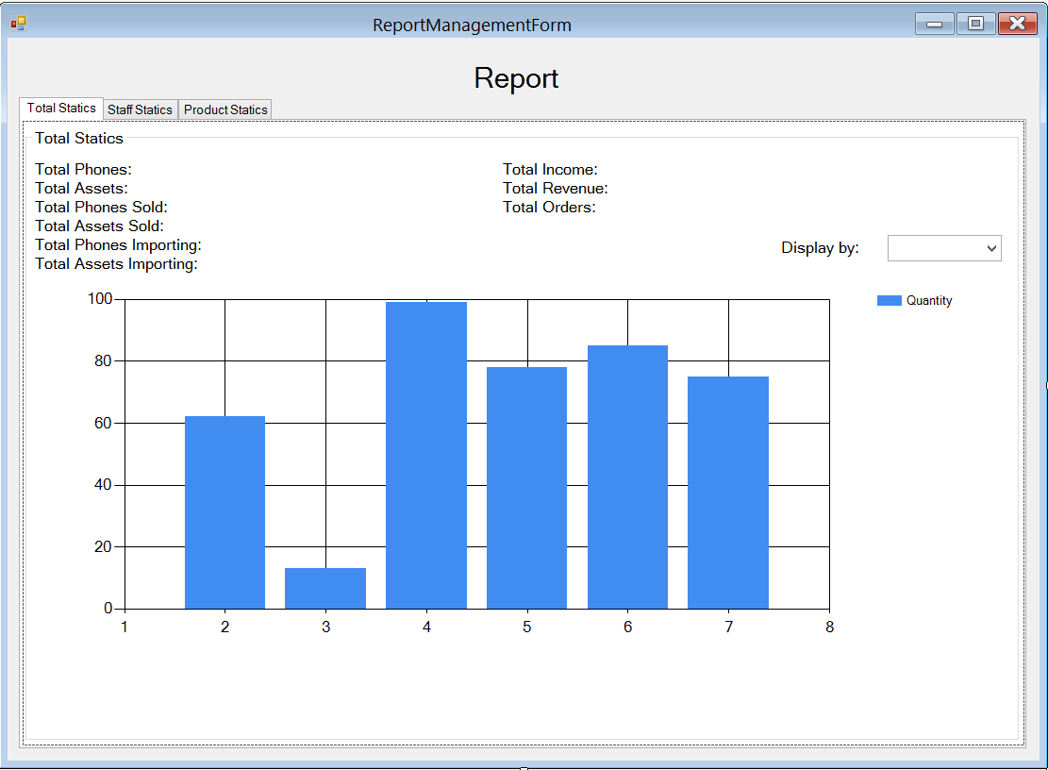

|  |  |  |  |  |  |
| --- | --- | --- | --- | --- | --- |
| **Screen** | Report Management - Total statics | | | | |
| **Description** | | Allow Administrator and Managers view their total statics in a month. | | | |
| **Screen Access** | | Users run program then click on **Report** button | | | |
| **Screen Content** | | | | | |
| **Item** | | **Type** | **Data** | **Description** | |
| Tab Total Statics | | Tab |  | Titles | |
| Total Phone | | Label – String (50) | Count all available phones in table PHONE | Display total available phones in DB. | |
| Total Assets | | Label – String (50) | Count all available phones in table ASSET | Display total available assets in DB. | |
| Total Phone Sold | | Label – String (50) |  | Display total phones sold. | |
| Total Assets Sold | | Label – String (50) |  | Display total assets sold. | |
| Total Phone Importing | | Label – String (50) | Count all available phones which are importing in table ORDER | Display phones which are importing. | |
| Total Assets Importing | | Label – String (50) | Count all available assets which are importing in table ORDER | Display assets which are importing. | |
| Total Income | | Label – String (50) |  | Display total income. | |
| Total Revenue | | Label – String (50) |  | Display Total Revenue | |
| Total Orders | | Label – String (50) |  | Display Total Orders | |
| Display by | | Drop down list – String (50) |  | Display information in chart below by total phones, assets; total phones, assets sold; total importing phones, assets; total income, revenue, orders. | |
| Chart | | Chart |  | Display data when user choose an item from dropdown list.  X-axis is days of a month.  Y-axis is quantity.  The chart in the image above is just an example. | |
| **Screen Actions** | | | | | |
| **Action Name** | | **Description** | | **Success** | **Failure** |
| Choose | | Choose an item from combo box “Display by:” | | Display information to the chart below. | Display message: “Database connection error.” |

### Report – Staff Statics

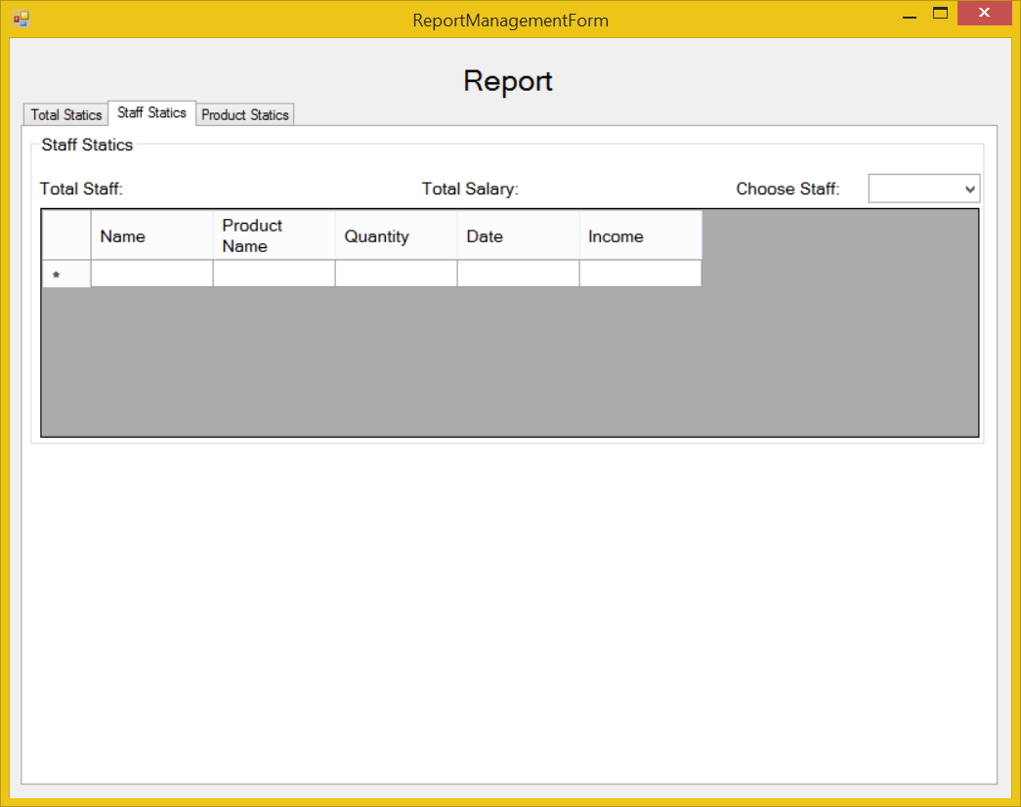

|  |  |  |  |  |  |
| --- | --- | --- | --- | --- | --- |
| **Screen** | Report – Staff Statics | | | | |
| **Description** | Allow Administrator and Managers view their statics about staff members. | | | |
| **Screen Access** | Users run program by click on file **Report -> Staff Statics** | | | |
| **Screen Content** | | | | | |
| **Item** | **Type** | **Data** | **Description** | |
| Staff Statics | Tab |  | Tab name | |
| Staff Statics | Label – String (50) |  | Name of the staff statics group | |
| Total Staff | Label – String (50) | Look up from STAFF, count all of available staff members in DB except Administrator. | Display total available staff members in DB. | |
| Total Salary | Label – String (50) |  | Display total available salary of all staff members in DB. | |
| Choose Staff | Combo box | Look up from STAFF.STAFFCODE | Choose a staff code from the dropdown list to view information at a specific staff member in data grid view below. | |
| Data grid view | Data grid view |  | * Display all fields about the staff when the staff code is chose: Name, product name, quantity, date, income. * This table is read-only, user cannot edit it. | |
| **Screen Actions** | | | | | |
| **Action Name** | **Description** | | **Success** | **Failure** |
| Choose. | Choose an item from combo box “Choose Staff:” | | Display information to the data grid view below. | Display message: “Database connection error.” |

### Report – Product Statics

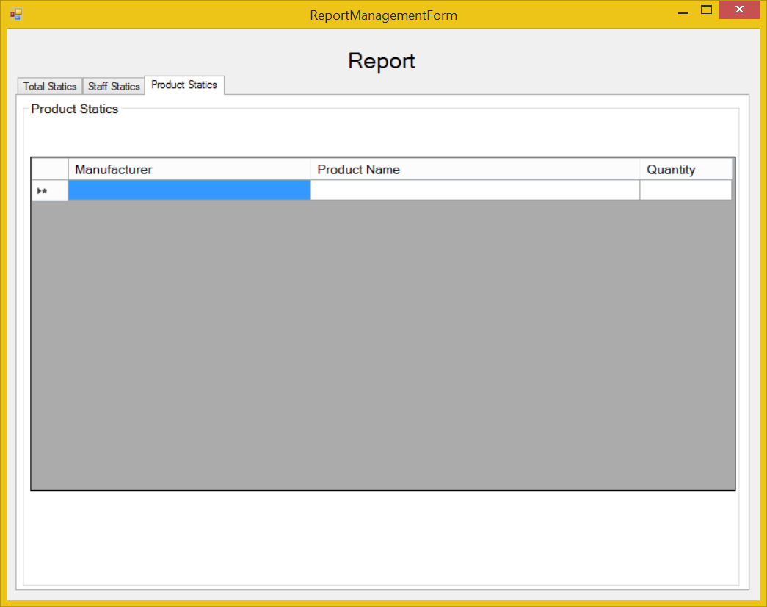

|  |  |  |  |  |  |
| --- | --- | --- | --- | --- | --- |
| **Screen** | Report – Products Statics | | | | |
| **Description** | Allow Administrator and Managers view their statics about products. | | | |
| **Screen Access** | Users run program by click on file **Report -> Product Statics** | | | |
| **Screen Content** | | | | | |
| **Item** | **Type** | **Data** | **Description** | |
| Products Statics | Tab |  | Tab name | |
| Products Statics | Label – String (50) |  | Name of the Products statics group | |
| Data grid view | Data grid view | Look up from PHONE.MANUFACTURER and ASSET.MANUFACTURER join with PHONE.NAME and ASSET.NAME then count all them. | * Display all fields about the Products when the form loaded: Manufacturer, product name, quantity. * This table is read-only, user cannot edit it. | |
| **Screen Actions** | | | | | |
| **Action Name** | **Description** | | **Success** | **Failure** |